PowerTricks

Dataverse Training

Note for Admins

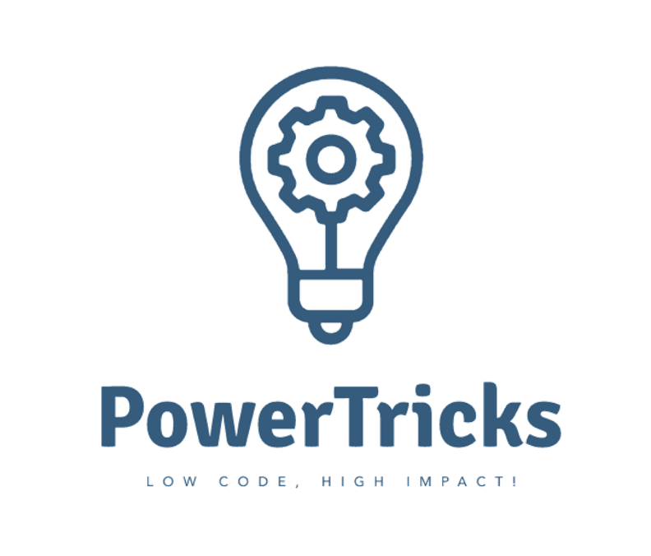

Version History

|  |  |  |  |
| --- | --- | --- | --- |
| Version | Date | Author | Comments |
| 1.0 | 01/12/2023 | [Valentin Mazhar](https://www.linkedin.com/in/valentin-mazhar/) | First version of the Note for Admins |

Table of Contents

1. Introduction 3

2. Format and materials 3

3. Pre-requisites 3

4. Recommendations 4

5. Labs change history 5

6. Feedback 5

# Introduction

Welcome to the PowerTricks Dataverse Lab.

I am [Valentin Mazhar](https://www.linkedin.com/in/valentin-mazhar/) and created the training materials of this course. I am sharing them publicly via my [PowerTricks blog](https://powertricks.io/) and [GitHub repo](https://github.com/ValentinMaz/Power-Platform-Samples).

I created these labs because so far Microsoft Learn only contains isolated Learning Paths about Dataverse, each addressing a different aspect with a different scenario, without delivering a single comprehensive training which would cover most Dataverse features. These labs are heavily inspired from some of the existing Microsoft Learn materials, such as the leading use case and data samples.

Since these labs require the participants to manipulate Dataverse, they will need to have access to an Environment where they have the appropriate permissions to follow the Labs.

This document is intended for the team responsible for the Power Platform Governance within the organization. It contains the pre-requisites and suggestions to optimize the experience of the participants who will follow the labs.

# Format and materials

The labs are designed in 6 progressive chapters and are essentially written instructions. The participants will need to have access to an environment with sufficient permissions to complete the labs. Apart from the access and permissions part which require the action of the admins, the participants should be able to complete all the labs just by following the instructions.

The instructions are intended to be detailed enough for anyone to complete the labs without requiring any support. However I would still suggest for Admins and support teams to still expect to be contacted about them. I might not have explained every step as clearly as needed for everyone.

# Pre-requisites

## Participants’ experience

These labs are intended for individuals who are **familiar with the Power Platform**. They do not need to be an expert but should have ideally already **created some Cloud Flows and Canvas Apps in the past**. Prior **experience with Dataverse is not required**. If the participants are not familiar with Power Apps and Power Automate, they will have a better experience if they complete the free online [Power Platform Fundamentals training](https://learn.microsoft.com/en-us/training/paths/power-plat-fundamentals/) before following these labs.

Experience with Power BI is only optional and will only be necessary if the participants want to practice with connecting to Dataverse from Power BI desktop.

## Technical set-up

To complete all the labs, each participant will need access to an Environment:

* A Dataverse database needs to be provisioned,
* They need System Administrator rights over that environment,
* The Dataverse and Office 365 Outlook connectors need to be enabled on that Environment.

They will also need to have Power BI desktop if they want to connect to Dataverse from Power BI desktop. This is optional and skipping this module will not prevent them from following the rest of the labs.

The licensing requirements will depend on the type of Environment which is provisioned for them to complete the labs.

The [personal Developer Environment](https://learn.microsoft.com/en-us/power-platform/developer/plan) is a particularly interesting type of environment for this training. It would allow each participant to have their own environment and leverage Dataverse without requiring premium licenses.

# Recommendations

Each organization is unique in their approach of delivering user trainings and governing the Power Platform. I recommend following the steps below to roll out these labs in the organization.

1. **Review and customize the labs**

Ensure the labs fit with the internal strategy and add internal links whenever relevant. I provide the editable files in .docx format so that they can be adjusted and re-branded as needed.

1. **Define the technical set-up**

Define which environments will be provided to the participants. Each participant should have their own environment to be able to complete the labs in their current state. If you plan to use the same environment for all participants, it will require some adjustments in the labs. I recommend considering the below options:

1. **Leverage the personal** [**developer environments**](https://learn.microsoft.com/en-us/power-platform/developer/plan). Either create each participant’s environment on their behalf as needed, or allow the self-service creation of developer environments. No premium licenses will be needed but this will require the organization to have a strategy in place to govern such environments.
2. **Create a** [**trial environment**](https://learn.microsoft.com/en-us/power-platform/admin/trial-environments) **for each participant**. The environments will be automatically deleted at the end of the training. No premium licenses will be needed but this will require the participant to complete the labs within the 30-day of the environment’s validity period.
3. **Create permanent standard environments dedicated to the labs.** At the beginning the environments and access would be reset. Participants would be granted the system admin role on the environment assigned to them during the duration of the labs. One they have completed the labs their access would be removed and the environment would be reset. Participants would require appropriate licenses and this method would not be adapted to make the labs available for the entire organization.
4. **Define the delivery model**

Assess whether the training should be self-pace or delivered by a trainer. The labs themselves are designed to be followed in a self-pace fashion. However, the participants could have a better experience if actual training sessions are organized to also explain some theory and provide company-specific information. I recommend considering the below approach:

1. Select a few volunteers interested in learning about Dataverse.
2. Schedule 6 x 2-hour training sessions with a trainer and the volunteers, 1 session per chapter.
3. The trainer will start each session by presenting some theory about Dataverse and share their screen for some demos during the first hour. The participants will then complete the labs of the chapter during the second half of the sessions. If they have any questions the trainer will be able to support them. If they haven’t finished the lab by the end of the session, they will have to complete them before the next session.
4. Get the feedback from the participants. If it is successful and if everyone in the organization can have access to their own environment, use the recordings of the theory part of each session to make the training and materials available more widely in the organization.

# Labs change history

If I ever update the labs hosted on my [GitHub repo](https://github.com/ValentinMaz/Power-Platform-Samples/tree/main/Dataverse%20Training%20Labs) I will indicate it in this section.

|  |  |  |  |
| --- | --- | --- | --- |
| Version | Date | Author | Comments |
| 1.0 | 01/12/2023 | [Valentin Mazhar](https://www.linkedin.com/in/valentin-mazhar/) | First version of all labs, split in 6 chapters |

# Feedback

I would love to hear your feedback about this training or anything else related to my blog. Please reach out via the [PowerTricks Contact section](https://powertricks.io/contact/), creating an [issue in GitHub](https://github.com/ValentinMaz/Power-Platform-Samples/issues) or directly via [LinkedIn](https://www.linkedin.com/in/valentin-mazhar/)!